**Looking at Current Learning Together**

When looking through the current learning examples ask questions to get an understanding of what your child is learning:

* What were you learning here?
* How easy or difficult did you find this work?
* Was this work you enjoyed? Why/why not?
* With the child you may choose to “Traffic Light” work you all think is particularly good or that needs more effort, attention or learning.
  + Green, amber or red – the pupils can explain this further.
* At Fernielea we use the left hand page of our ‘snapshot’ jotters to record our current progress and our reflections on learning.
* ***Please use the left hand page in the snapshot jotter to record your comments, observations, encouragement and suggestions for your child’s work to develop.***

**If for any reason you do not feel able to comment on the children’s work or to write the target – please do not worry – the DISCUSSION about learning you have with your child is the most important thing.**

**How Do We Share Learning?**

At the planned Families Learning Together (FLT) sessions you will be welcomed by a P7 pupil who will find you a seat in the hall and go and collect your child and their selection of work.

* There will be set of **learning questions** available to help you with the discussion.
* Look through the **work** your child has brought and ask them any **questions**.
* Together you may choose to write any comments on the left hand page of a jotter.
* The pupil will have a sheet which you should fill out together with your child. This is a **target** for them to work on for next time.
* When you are finished, the P7 will accompany the child back to class and will give the agreed target sheet to the class teacher.

**Why Share Learning?**

A vast amount of research shows that one of the things which increases achievement for children is engagement from home in the child’s learning.

Where there is a shared understanding between pupils and home that learning is important, pupils do better and achieve more.

Where there is an understanding at home about what and how children are learning in school, pupils do better and achieve more.

Sharing learning regularly gives families a shared vocabulary for discussing learning. This helps home to engage better with the child and move beyond the all-too-familiar exchange:

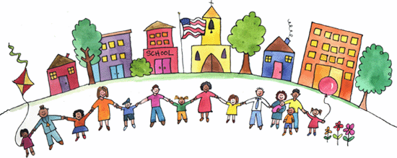

**Encourage, Support and Motivate**

Looking through work together and talking about it is a good opportunity to support pupils to be proud of what they have achieved and to encourage them to keep trying hard.

Praise is a great thing – but too much praise for not enough effort can make children lack the motivation to improve. Encourage, but also suggest where they need to improve.

How was school?

Fine!

**Who Can Share Learning?**

We are keen for home to be involved as much as possible so anyone from your home network who is interested in engaging with your child’s learning is welcome. E.g. parents and carers, grandparents, siblings, aunts and uncles, family friends, etc.

***For security – we need to know in advance who is going to attend.***

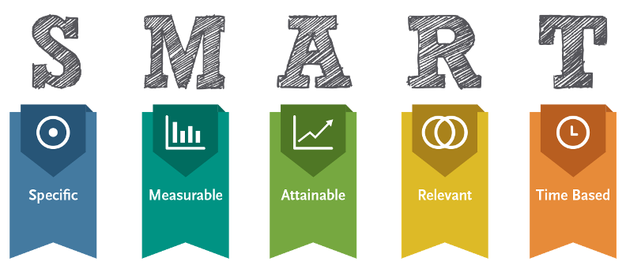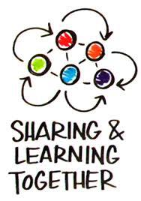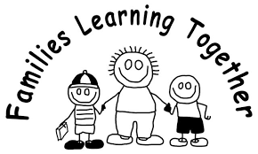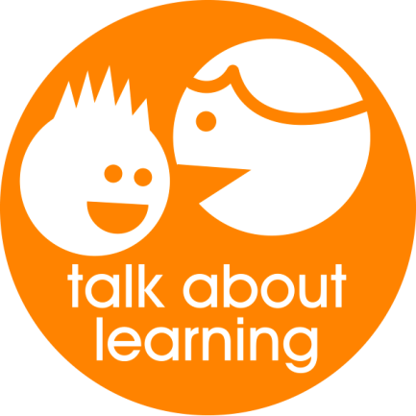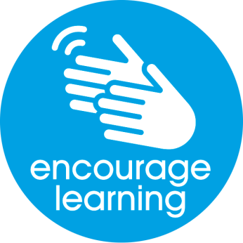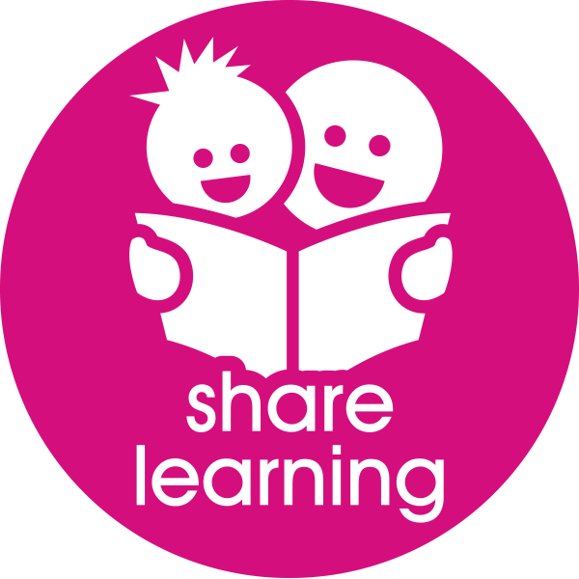

**Target Setting Next Steps Together**

Before your child goes back to class, we would like you to set a learning target together that your child can work on.

This can be about anything you’ve discussed and can be a very small thing. It is best to make these clear. For example:

* Instead of writing *“improve my handwriting”* it would be better to say *“All letters in my writing will sit on the line by next Friday”.*
* Instead of *“try harder”* you might agree *“write a longer story this week than last week.”*
* Instead of *“get better at mental”* you might choose *“get more than 15/20 in my mental test on Monday”.*

In school we talk about targets being SMART this means that they are:

* Specific – clear and easy to understand
* Measurable – there is a way to know if it’s been achieved
* Attainable – it’s not too far out of reach
* Relevant – it’s based on learning that is happening
* Time Based – It’s clear when this should be done by.

In school we can never arrange everything to suit all home situations.

We have planned the days and times of this year’s Families Learning Together sessions on a variety of days and at a variety of times.

Our hope is that while not all parents/carers will be able to make them all – someone from home should be able to make some of them.

**FLT1** Tuesday 4th December 2pm

**FLT2** Friday 1 March -11am

**FLT3** Tuesday 28th May – 2pm

Come along and talk with your child about their learning.

Share the learning.

Fernielea Families Learning Together

Programme Session 2018/2019