Fernielea
Return to School Guide August 2021
N-P3 Return
Welcome back to Fernielea for the 2021/22 year!
The plan is to return to the same level of restrictions as set out by the Scottish Government that were in place in June 2021. These may change but this is the most up to date information at this time.
The guidance issued by the Scottish Government reiterates the need for schools to continue to follow strict COVID-19 control measures and in keeping with the guidance, we have reviewed access and egress arrangements to ensure that we limit opportunities for children and parents to congregate (See below).
Staff, will routinely be reminding/guiding your child to:

- maintain regular handwashing,
- consider 2m distancing from staff and one another where possible
- where possible, not share resources with others

to ensure that everyone does all they can to keep themselves and members of their family safe.

We ask that parents remember to support the strict COVID-19 controls in place by
- not congregating at the school gates
- remembering FACTS.
- As we plan for the return, I ask you to help us by ensuring that you keep a strict 2m distance between yourself and other households during drop off and pick up
- continue to follow the general advice to wear face coverings when around others outwith your household.

Further arrangements in place to ensure that all in our Fernielea community are safe.
- Your child should not attend school or nursery with any COVID related symptoms no matter how mild.
- There will be no access to the school reception for adults so please make all enquiries via the school office by calling 01224 318533 or by emailing fernielea@aberdeencity.gov.uk
- The school carpark cannot be entered by anyone other than staff. No exceptions. All spaces are required to maintain safe levels of social distancing between staff.
- Parents of P2-7 pupils are asked to drop the children at the assigned gate and collect from that gate at the end of the day.
- Social distancing between adults MUST be adhered to – signage will be visible to assist.
- Parents/adults are NOT permitted in the school playground at any time of the day unless accompanying a Nursery pupil, P1 pupil or a pupil with additional support needs (by prior arrangement).
- The carpark is not to be used AT ALL – no exceptions.
- Do not arrive before your drop off/pick up time as this will cause crowding and increase the risk of community transmission – please be punctual.
- All adults must drop and go – no gathering around the perimeter will be permitted as social distancing is paramount to ensure the safety of your child and staff and to minimise the risk of community transmission.
- There will be measures in place to stop bubbles mixing throughout the school day.
- Children are asked to bring their snack and a water bottle to school. They need no other resources from home. They may take a school bag but no toys, pencil cases etc
- School Uniform should be worn in P1-P7 except for days when they have PE. PE will take place outside as much as possible. Therefore, children should be dressed appropriately on these days – no uniform is required. Spare clothes will be needed at times when feet or clothing get wet; these should be in your child’s bag at all times.

Entering and Leaving School Arrangements

All children will enter the school grounds via a designated gate for their specific class. There will be set times of arrival and pick up. This is detailed in the table below.

As it is vital that all unnecessary contact between adults is minimised, all children must be dropped off at the gate and the parent/carer leaves. You are asked to leave to minimise the number of adults around the perimeter of the school. Children should only be dropped off at their time and not earlier. This again will serve to minimise adults around the school.
On entering the playground, the child will go directly to their line and will be supervised by a member of staff in their line until they go inside. This is to restrict mixing of bubbles and to minimise the risk of community transmission.

If you are waiting to drop off or collect another child at a different time please move away from the gate and return only at the correct time.
At the end of the school day, when collecting your child please ensure that you are there at the time and not too early, as this will cause crowding around the gates. Please maintain 2 m distancing from others outwith your household.

P1 parents/carers to stand on a spot marked in the playground – this is to ensure 2m distancing is maintained.

Please see the table below detailing entry and exit information for each P4-P7 class.

I thank you for your continued support and patience in managing the COVID restrictions and requirements and I look forward to seeing you all in the near future.

Take care and stay safe.

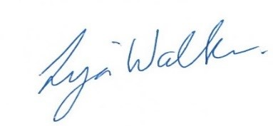

Fernielea School - Entering School Safely Guide

Class | Gate | Building Entrance | Start Time | End Time | Staff
Nursery  9-3 | 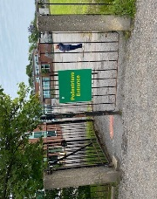  Gate 1 | Green Garden Gate  The normal garden entrance | From 9am | By  3pm | EYPs: Miss Walker, Miss Cuthill; Miss Black  SEYP: Miss Black  Support Worker: Miss Scott
Nursery AM | 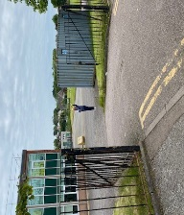  Gate 2 | Drop and go  Red Garden Gate  beside the large container  Collecting  Green Garden Gate  The normal garden entrance | From  8am | By  1pm | EYPs: Miss Willox, Miss Laing, Miss Nicol,  SEYP: Miss Black  Support Worker: Miss Scott
Nursery PM | Gate 1 | Drop and go  Red Garden Gate  beside the large container  Collecting  Green Garden Gate  The normal garden entrance | From  1pm | By  6pm | EYPs: Miss Willox, Miss Laing, Miss Nicol,  SEYP: Miss Black  Support Worker: Miss Scott
P1W | Gate 1 | Own Class Door Room 6 | 9.05am | 3.05pm | Miss Waddell
P1/2 | Gate 1 | Own Class Door Room 7 | 9am | 3pm | Mrs Duthie/Mrs Imrie
P2 | Gate 2 | 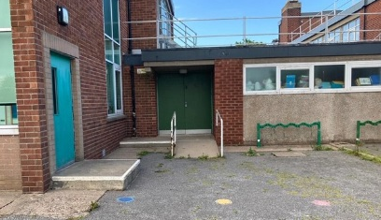  Back Entrance | 9am | 3pm | Mrs Middleton
P3B | 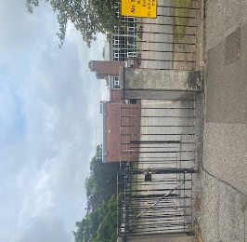  Gate 3 | Front Playground entrance  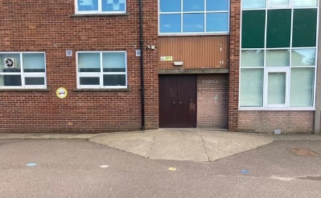 | 9.05am | 3.05pmpm | Miss Bain
P3D | Gate 3 | Front Playground entrance | 9am | 3pm | Miss Dyker
Room 14 | 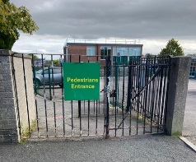  Gate 4 | Front Door  Via office | 9am | 3pm | Miss Steel, Miss Morrison

